Q1.
TCL script:
set ns [new Simulator -multicast on]
$ns color 1 Blue
$ns color 2 Red
set tracefile1 [open out.tr w]
$ns trace-all $tracefile1
set namfile [open out.nam w]
$ns namtrace-all $namfile

proc finish {} {
global ns tracefile1 namfile
$ns flush-trace
close $tracefile1
close $namfile
exec nam out.nam &
exit 0
}

set n0 [$ns node]
set n1 [$ns node]
set n2 [$ns node]
set n3 [$ns node]
set n4 [$ns node]
set n5 [$ns node]
set n6 [$ns node]
set n7 [$ns node]
set n8 [$ns node]

$ns duplex-link $n0 $n1 5Mb 2ms DropTail
$ns duplex-link $n1 $n2 5Mb 1ms DropTail
$ns duplex-link $n2 $n3 5Mb 1ms DropTail
$ns duplex-link $n0 $n4 5Mb 2ms DropTail
$ns duplex-link $n4 $n3 5Mb 2ms DropTail
$ns duplex-link $n3 $n5 5Mb 2ms DropTail
$ns duplex-link $n5 $n6 5Mb 2ms DropTail
$ns duplex-link $n5 $n7 5Mb 2ms DropTail
$ns duplex-link $n6 $n8 5Mb 2ms DropTail
$ns duplex-link $n7 $n8 5Mb 2ms DropTail

$ns duplex-link-op $n0 $n1 orient right-up
$ns duplex-link-op $n0 $n1 orient right-up
$ns duplex-link-op $n1 $n2 orient right
$ns duplex-link-op $n2 $n3 orient right
$ns duplex-link-op $n4 $n3 orient right-up
$ns duplex-link-op $n3 $n5 orient right
$ns duplex-link-op $n5 $n6 orient right-up
$ns duplex-link-op $n5 $n7 orient right-down
$ns duplex-link-op $n6 $n8 orient right-down
$ns duplex-link-op $n7 $n8 orient right-up

set mproto DM
set mrthandle [$ns mrtproto $mproto {}]

set tcp [new Agent/TCP]
$ns attach-agent $n0 $tcp
set sink [new Agent/TCPSink]
$ns attach-agent $n8 $sink
$ns connect $tcp $sink
$tcp set fid_ 1

set ftp [new Application/FTP]
$ftp attach-agent $tcp

set grp0 [Node allocaddr]

set udp [new Agent/UDP]
$ns attach-agent $n0 $udp
$udp set fid_ 2
$udp set dst_addr_ $grp0
$udp set dst_port_ 0

set cbr [new Application/Traffic/CBR]
$cbr attach-agent $udp

set rcvr1 [new Agent/LossMonitor]
set rcvr2 [new Agent/LossMonitor]
set rcvr3 [new Agent/LossMonitor]

$ns attach-agent $n6 $rcvr1
$ns attach-agent $n7 $rcvr2
$ns attach-agent $n8 $rcvr3

$ns at 0.3 "$n6 join-group $rcvr1 $grp0"
$ns at 0.3 "$n7 join-group $rcvr2 $grp0"
$ns at 0.3 "$n8 join-group $rcvr3 $grp0"

$ns at 0.1 "$ftp start"
$ns at 0.1 "$cbr start"
$ns at 89.5 "$ftp stop"
$ns at 89.5 "$cbr stop"

$ns at 90.0 "finish"
$ns run

Output:
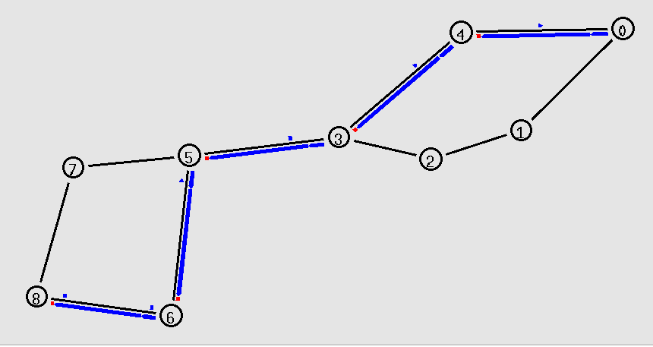

a. Find the maximum time taken by packet to reach at node 8 from source node, foreach type of traffic.

AWK script:
BEGIN {
max_time_ftp = 0;
max_time_cbr = 0;
}
{
if($5=="tcp"){
if($1=="r" && $4=="8"){
time_taken = $2 - $10;
if(time_taken>max_time_ftp) max_time_ftp = time_taken;
}
}
}
{
if($1=="+" && $4=="8"){
time_taken = $2-$10;
if(time_taken>max_time_cbr) max_time_cbr = time_taken;
}
}
END{
print("Max time taken by ftp packets: ",max_time_ftp);
print("Max time taken by cbr packets: ",max_time_cbr);
}

Output:
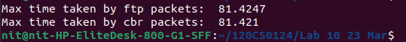

b. Find the number of packets received at node 8, for each type of traffic.

AWK script:
BEGIN {
cbr=0;
ftp=0;
}

{
if($5=="tcp"){
ftp=ftp+1;
}
if($5=="cbr"){
cbr=cbr+1;
}
}

END {
printf("------------Total number of packets-------------\n");
printf("Number of ftp packets: %d\n",ftp);
printf("Number of cbr packets: %d\n",cbr);
}

Output:
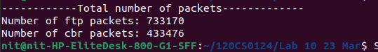

Q2.
AWK script:
BEGIN {
recv=0;
gotime = 1;
time = 0;
time_interval=1;
}
#body
{
event = $1
time = $2
node_id = $3
level = $4
pktType = $7
packet_size = $8;

if(time>gotime) {

print gotime, (packet_size * recv * 8.0)/1000; #packet size * ... gives results in kbps
gotime+= time_interval;
recv=0;
}

#========Calculate throughput==========

if (( event == "r") && ( pktType == "tcp" ) && ( level=="AGT" ))
{
recv++;
}

} #body

END {
;
}

Output:
